2025

Raymond Mabowa ST10438103

Rosebank College

8/8/2025

Project Proposal

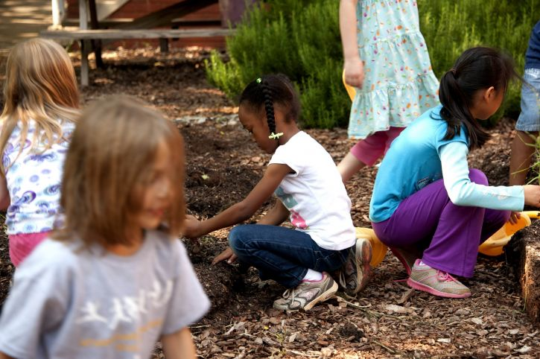

**GreenEarth Initiative**

Type: Nonprofit

Organization Goal: To encourage sustainable living, conservation, and environmental awareness via advocacy, education, and community involvement.

It targets students, teachers, environmentalist, funders and members of the public are the target audience.

**Website Objectives and Goals**

The main objective is to develop an engaging, userfriendly website that advances GreenEarth Initiative's online visibility and advances it’s objectives.

Goals: Inform people about environmental problems and their fixes. Publicize forthcoming campaigns, events, and volunteer opportunities. Organize fundraising events and donations. Give teachers and students resources. Create a community of people who care about the environment.

**Analysis of Current Websites (if appropriate)**

Now, GreenEarth has a simple, informative website with little functionality: outdated layout and inadequate responsiveness on mobile devices. lack of a content management system (CMS), which makes changes challenging. Few features for participation and interaction. No event registration system or donation gateway

**Pain Points**

Low engagement and retention of users. Discoverability and SEO are poor. not used by people with impairments.

Suggested Features and Functionality of the Website Modern web standards will be used in the construction of the new website, which will feature:

| Feature | Description |
| --- | --- |
| Responsive Design | Optimized for desktop, tablet, and mobile devices. |
| CMS Integration | WordPress or Drupal for easy content updates. |
| Donation Portal | Secure donation points such as selected shops and stores |
| Event Calendar | Interactive calendar with registration options. |
| Blog & News Section | Regular updates on environmental topics and organizational news. |
| Volunteer Sign-Up | Forms and database integration for volunteer management. |
| Educational Resources | Downloadable materials, videos, and lesson plans. |
| Social Media Integration | Live feeds and sharing buttons. |
| Accessibility Compliance | WCAG 2.1 standards for inclusive design. |
| Multilingual Support | English and other regional languages. |

**Principles of Design and User Experience:**

Clean, earthy, and green-toned design that draws inspiration from nature. Clear calls to action and easy navigation. excellent infographics and images. Minimal clutter and quick load times.

**Goals for the User Experience**

Key information is easily accessible. smooth registration and donation procedures. interesting material that promotes return visits.

**Technical specifications**

* CMS: WordPress with plugins and a unique theme.
* Security measures include firewall protection, frequent backups, and SSL certificates.
* SEO: Sitemap integration, metadata, and on-page optimization.
* Analytics: Heatmap tools and Google Analytics.
* Database: managing users and content related matters
* Compliance: Data protection through adherence to GDPR and POPIA.

| Phase | Tasks | Duration |
| --- | --- | --- |
| 1. Discovery & Planning | Stakeholder meetings, requirement gathering | 2 weeks |
| 2. Design | Wireframes, mock-ups, user feedback | 3 weeks |
| 3. Development | Front-end and back-end coding, CMS setup | 4 weeks |
| 4. Testing | Usability, performance, and security testing | 2 weeks |
| 5. Launch | Final deployment and promotion | 1 week |
| 6. Post-Launch Support | Bug fixes, updates, and training | Ongoing |

**References**

GreenEarth Cleaning, 1999. A Kinder Green [Online] Available at: <https://greenearthcleaning.com/> [Accessed 6 August 2025]